Temasek Polytechnic

School of Informatics & IT

****Agile Methodology and Design Thinking****

****AY2022/2023 April Semester****

****Project Part 3****

**Case Study Prototype (40%)**

|  |  |
| --- | --- |
| Name: | {Carolyn Mohanty } |
| Admission Number: |  |
| Class: | {P01 } |

Table of Contents

Prototype: Hi-Fi Wireframes (40 marks) 3

Use Case Diagram with Descriptions (30 marks) 4

Prototyping Sprint Activities in JIRA(40 marks) 5

# Prototype: Hi-Fi Wireframes (40 marks)

Please insert your screenshots of the Wireframes.

Please also insert the link of your prototype if you use some online tools.

There are too many pages to screenshot so here is the link to my high-fidelity prototype:

<https://xd.adobe.com/view/8ce3f3de-9411-407b-9249-d5b6b2225fdc-d9b0/>

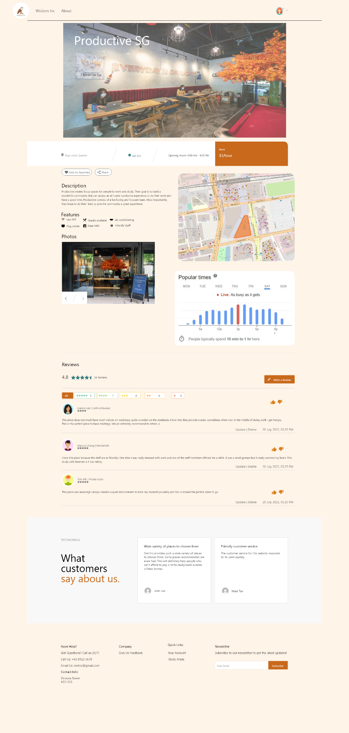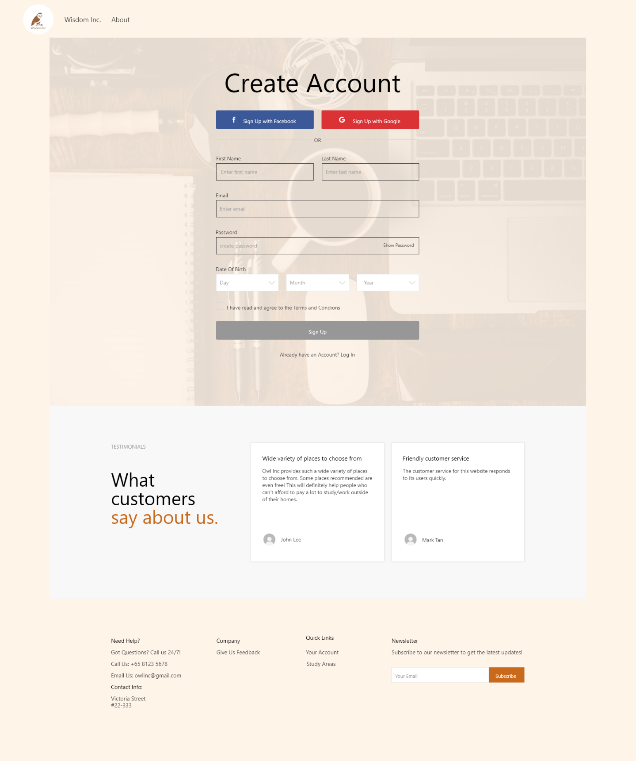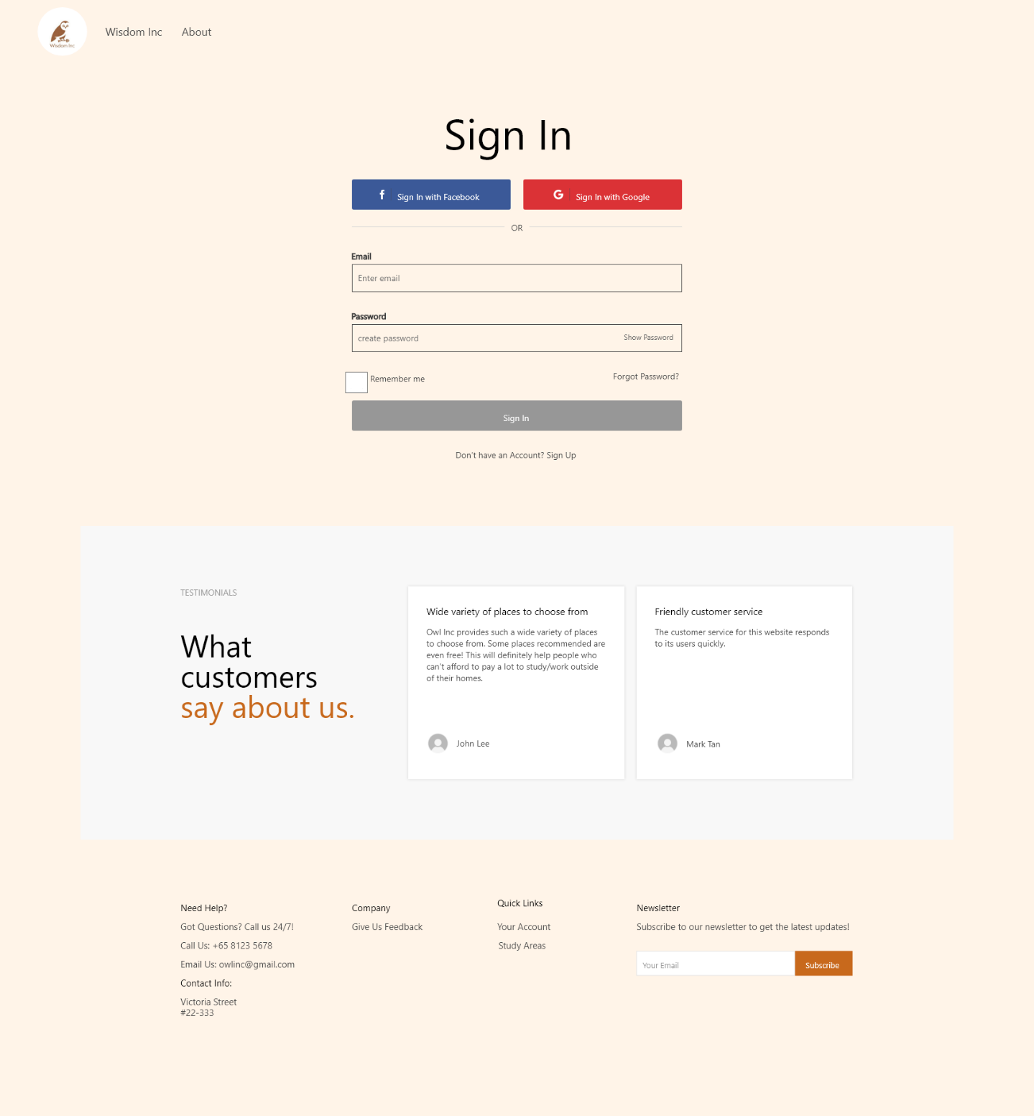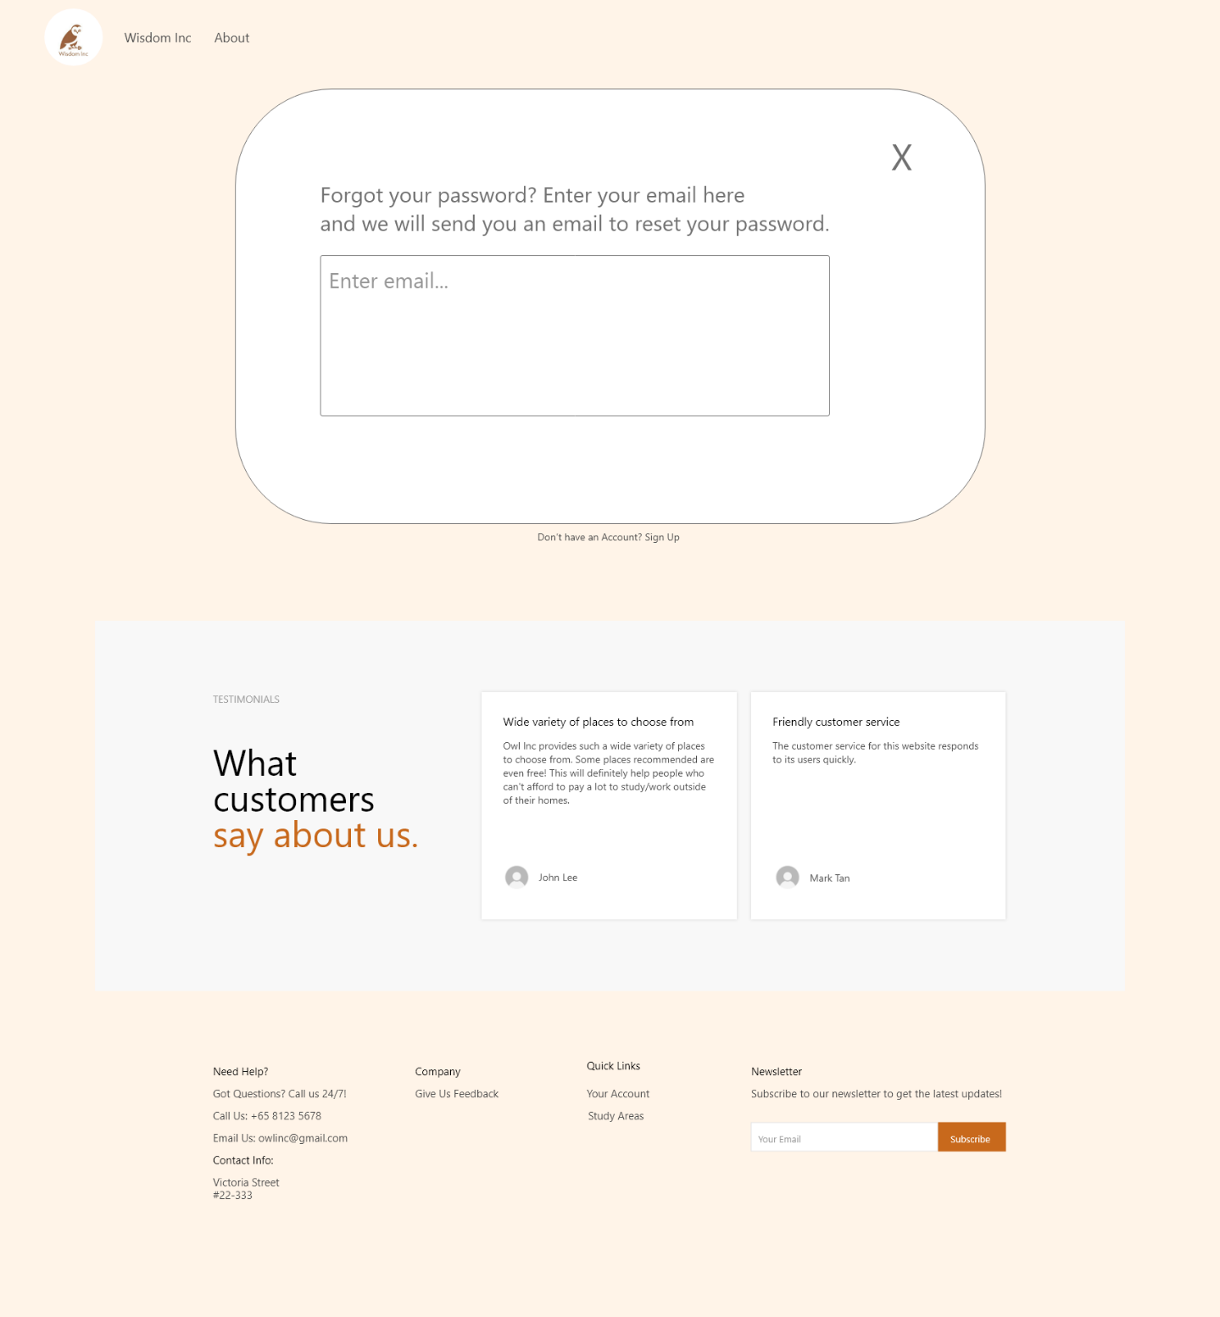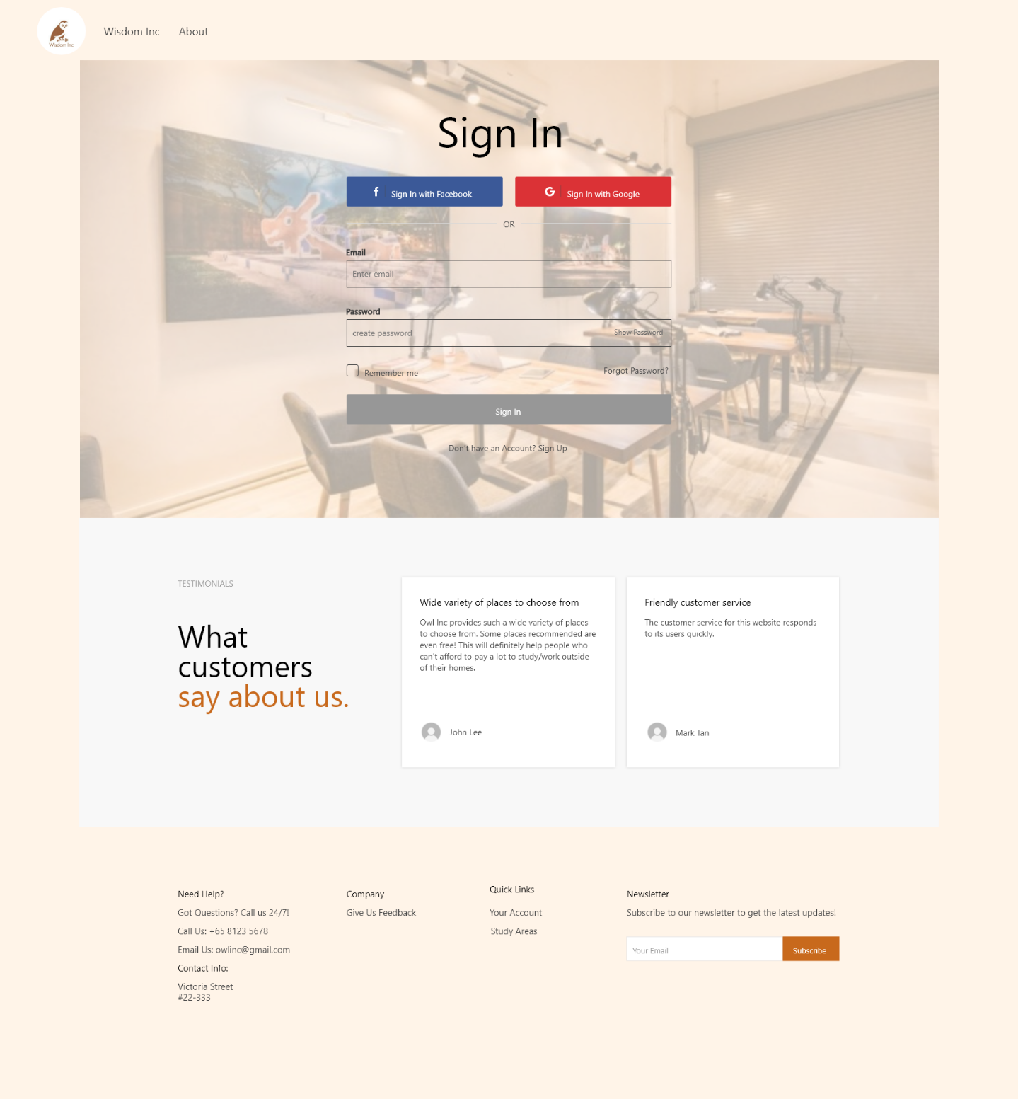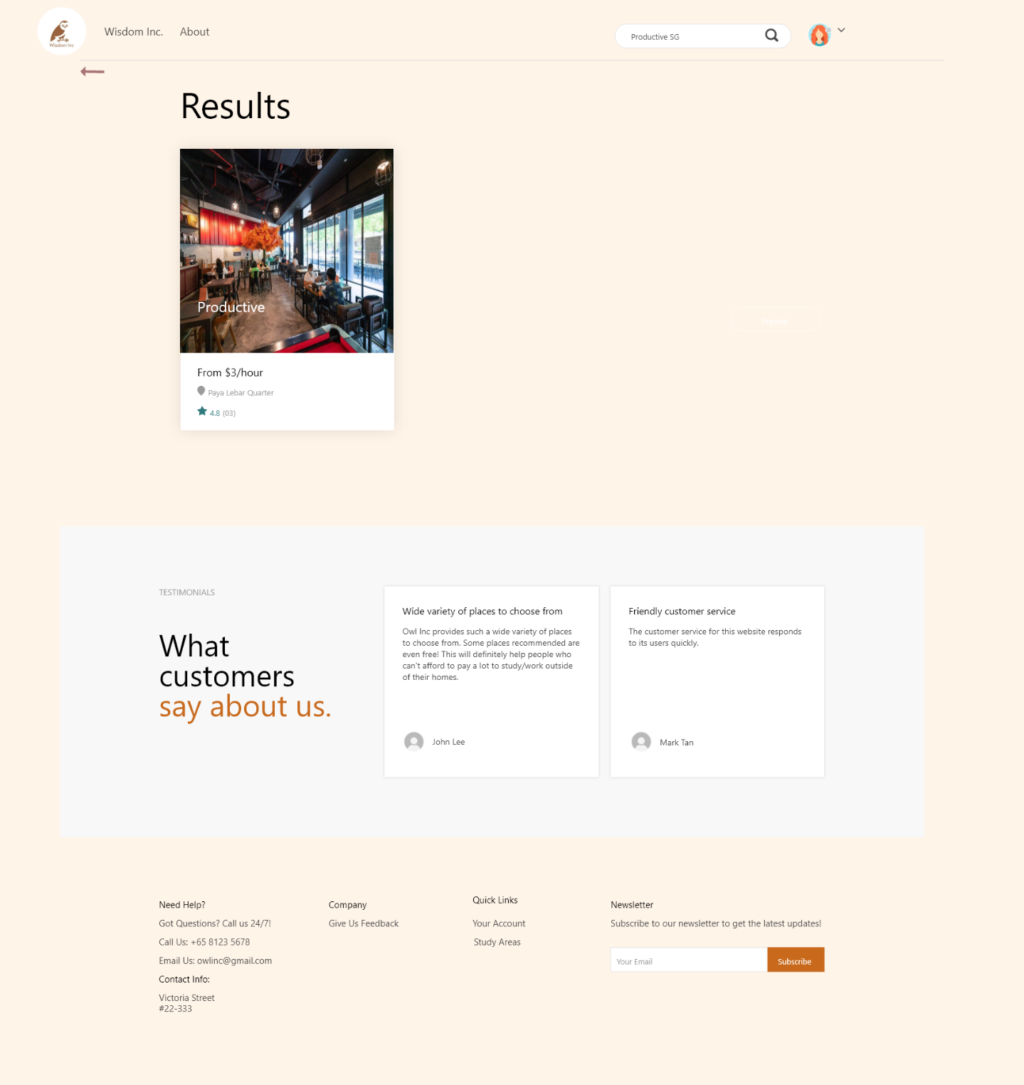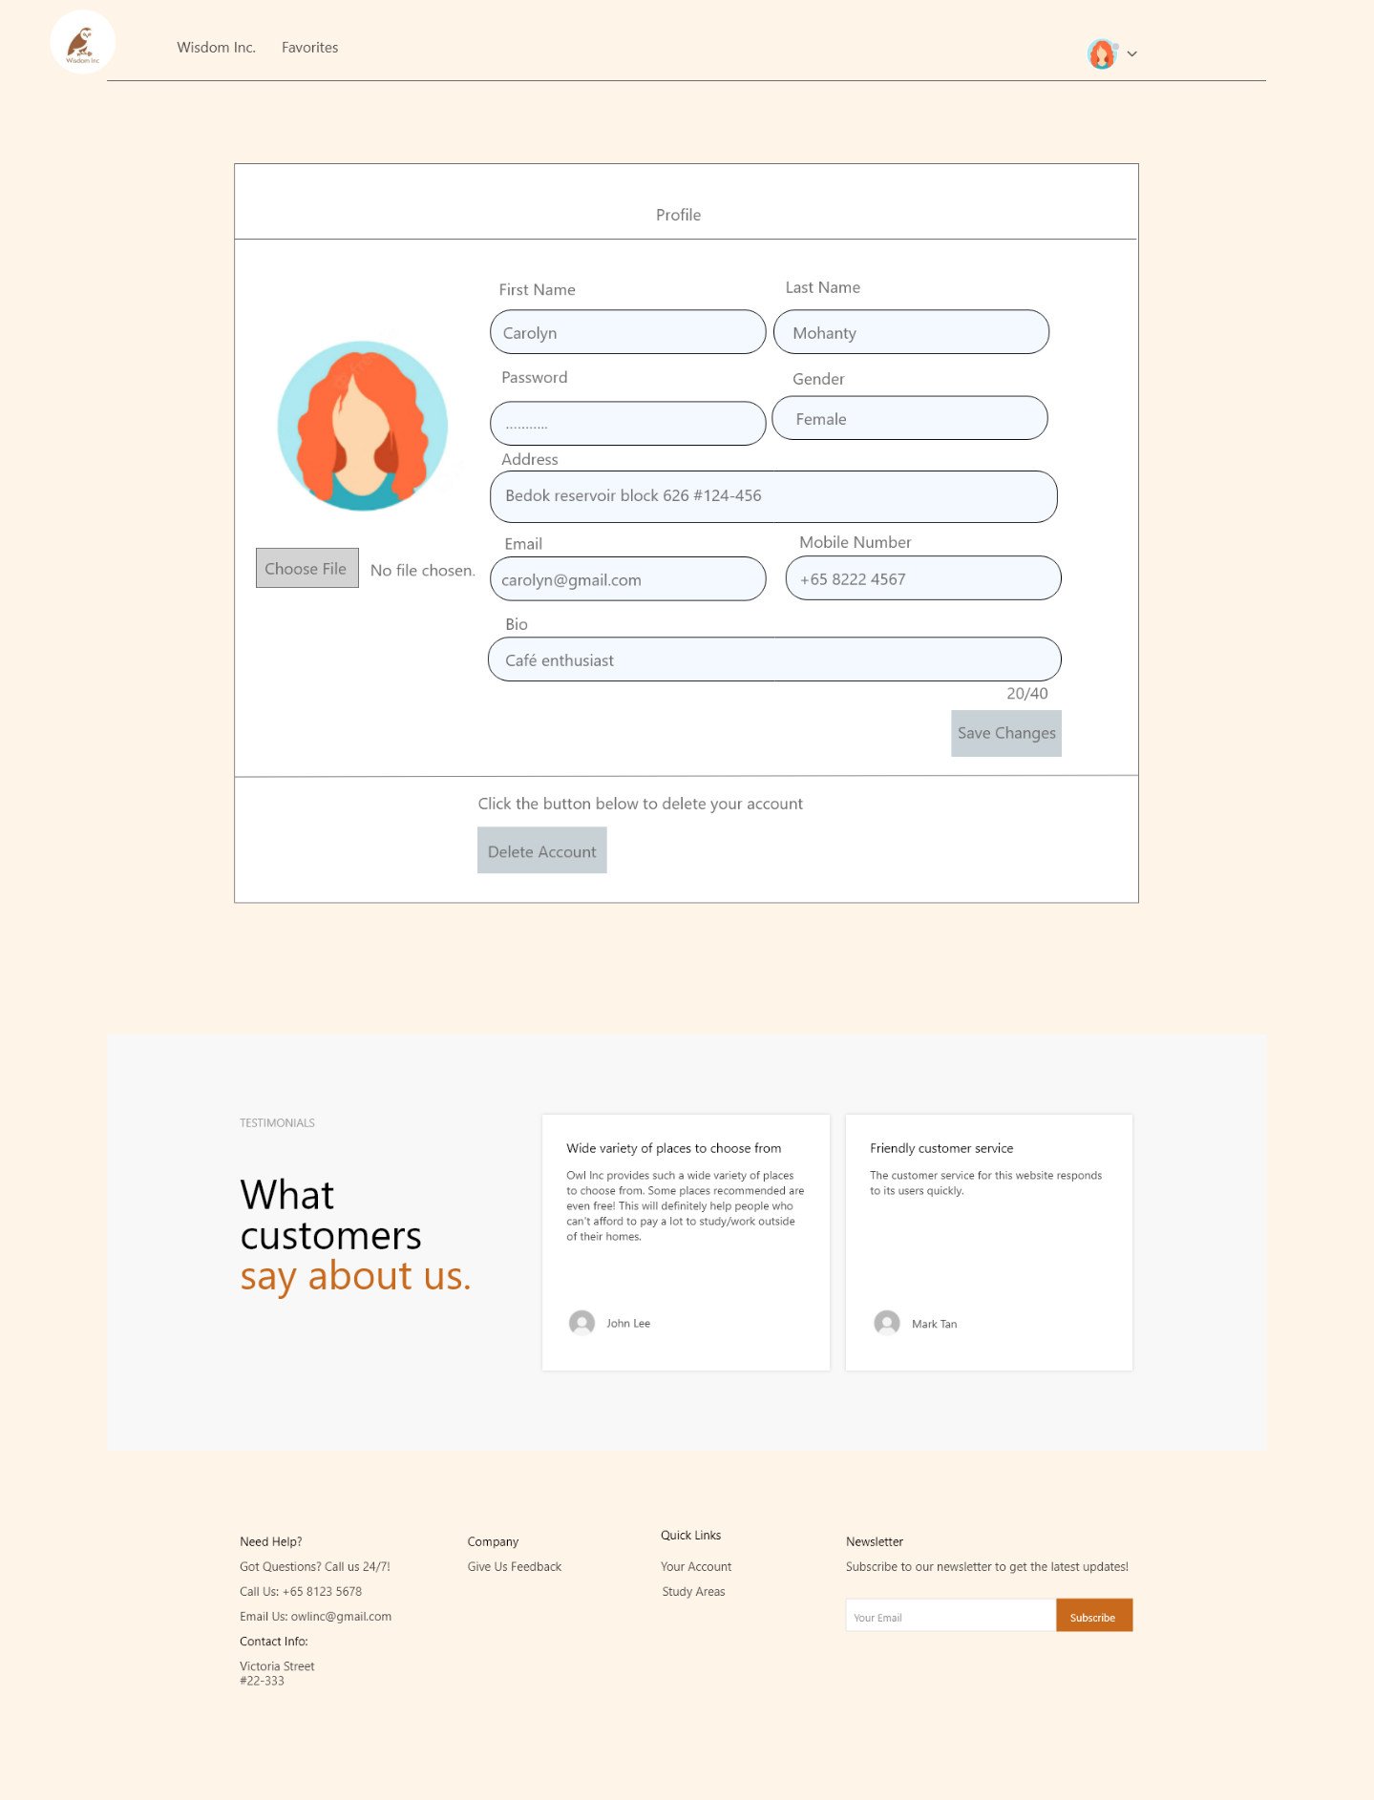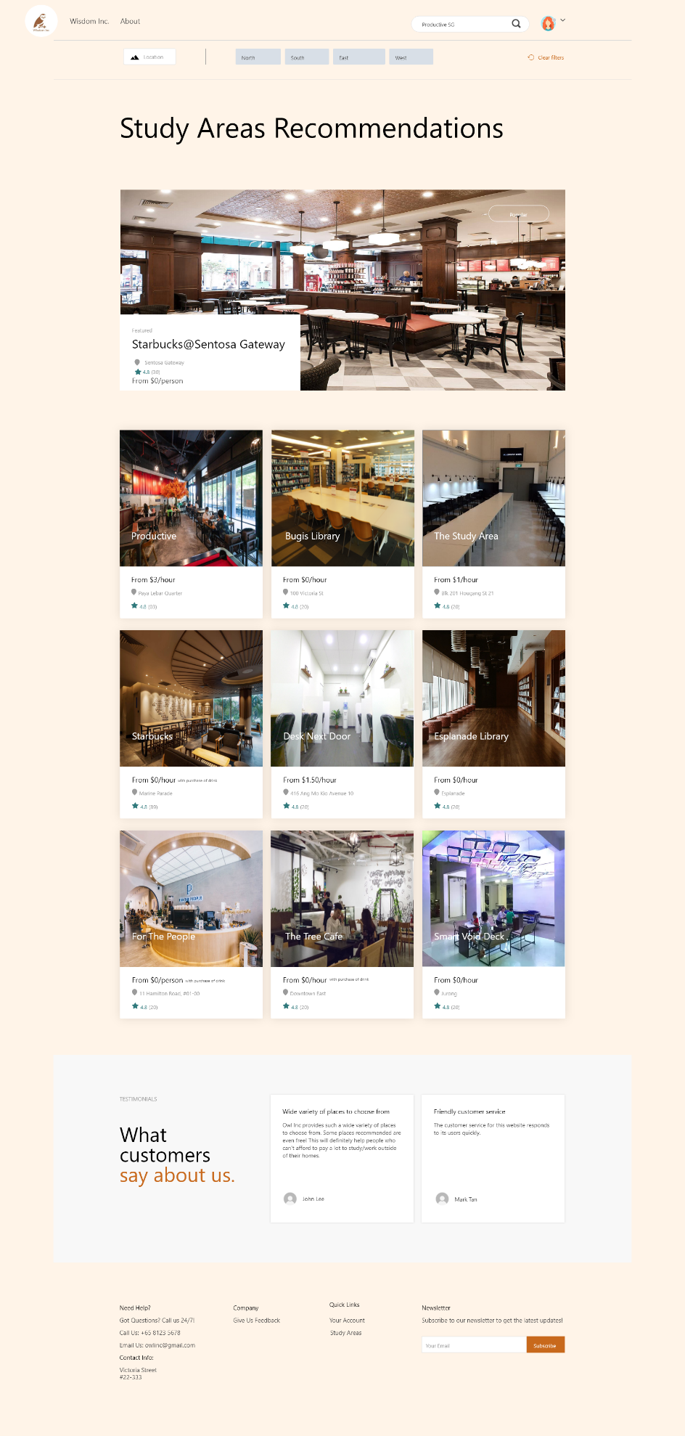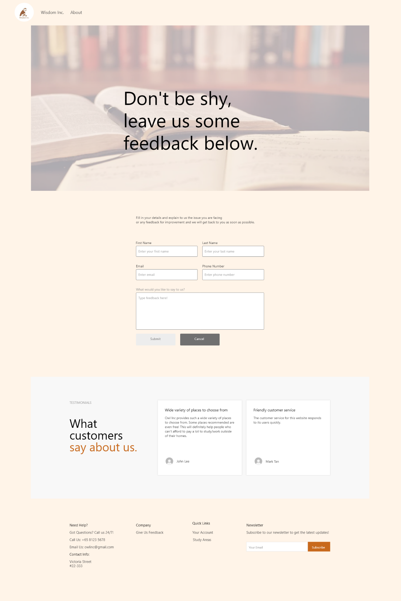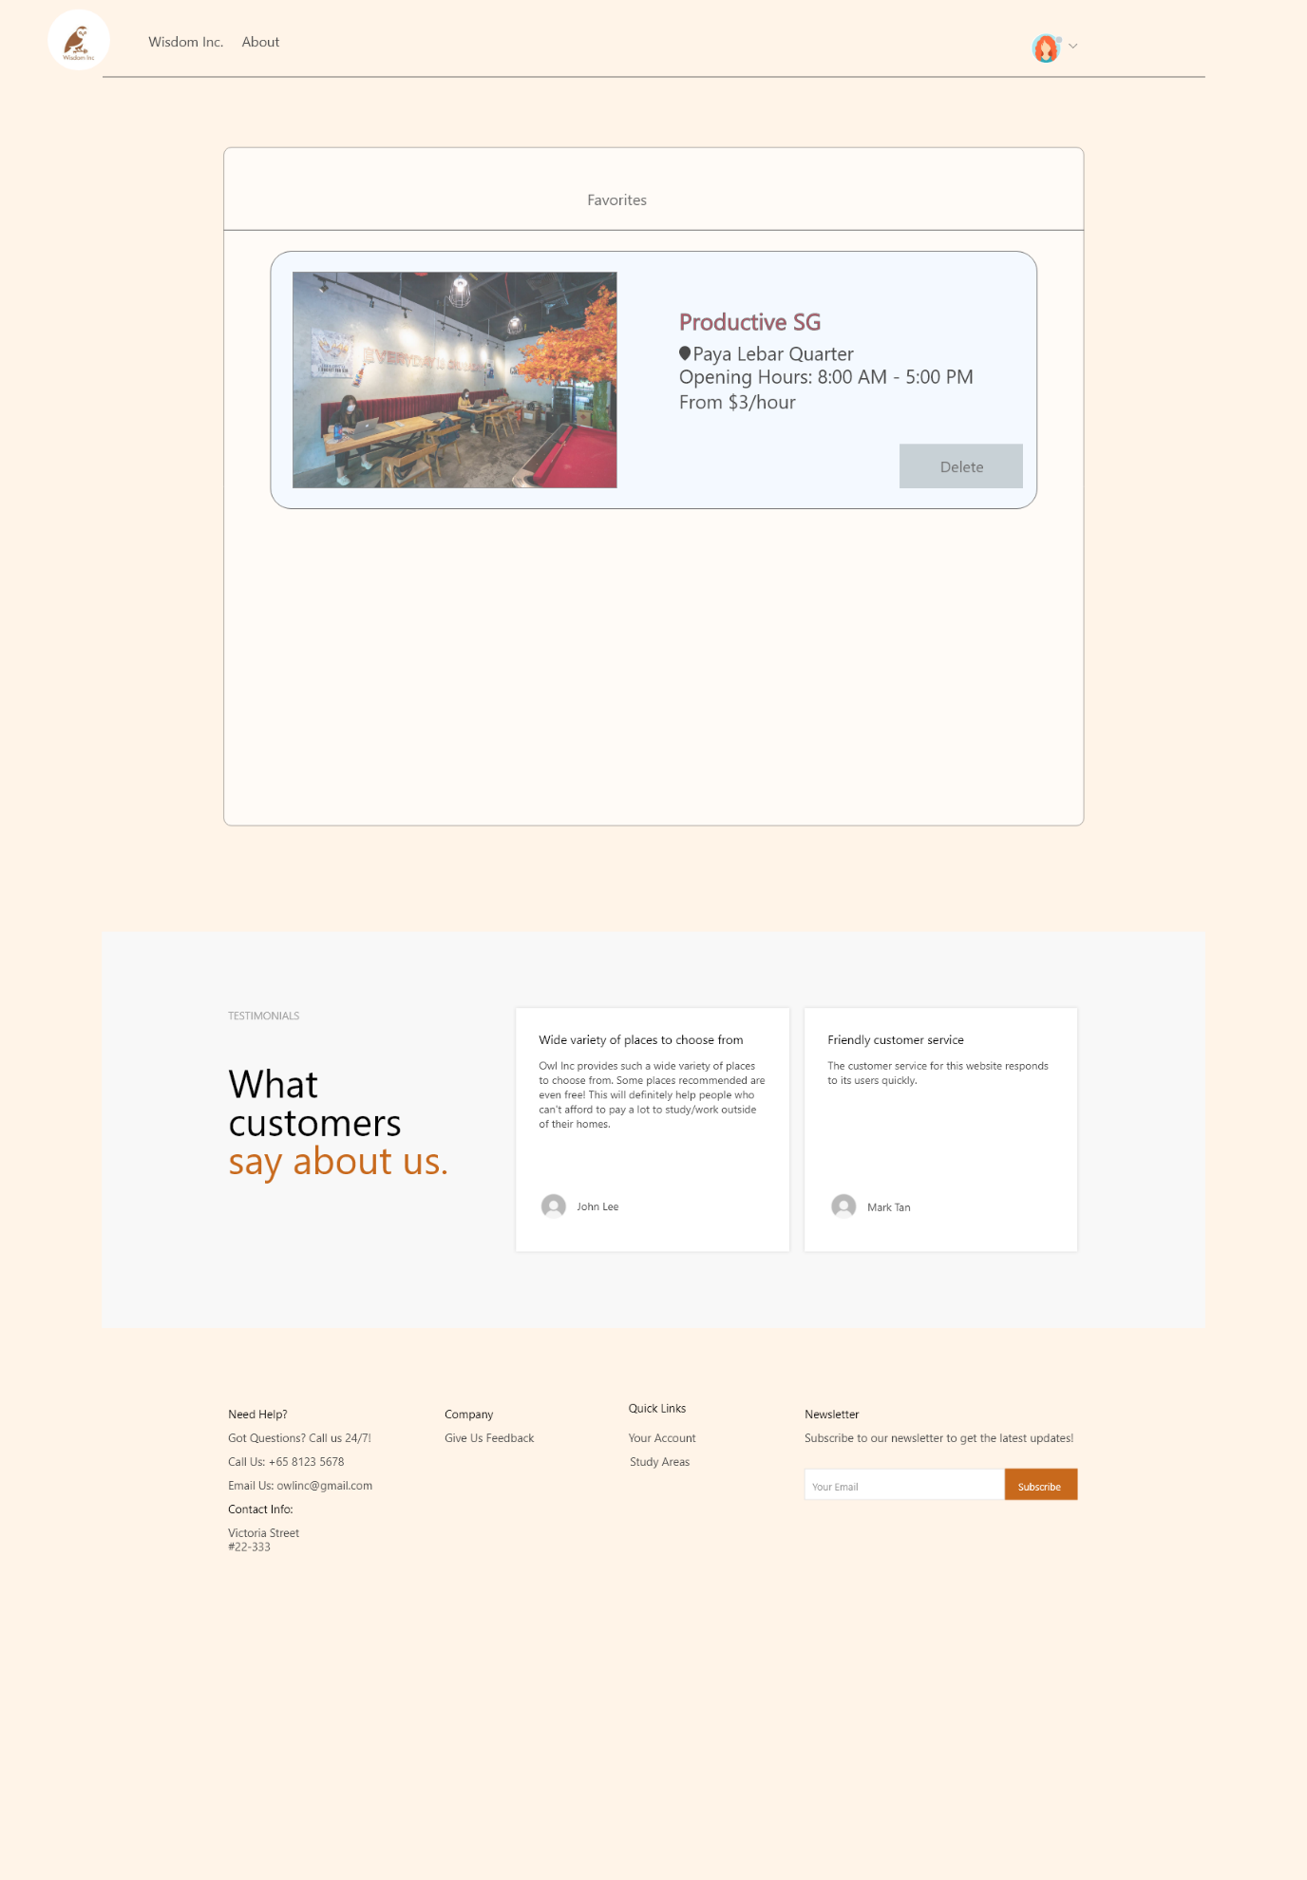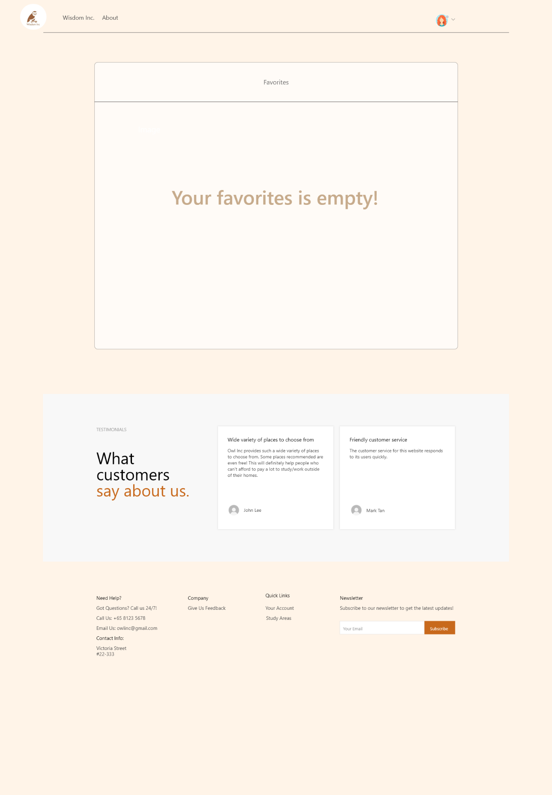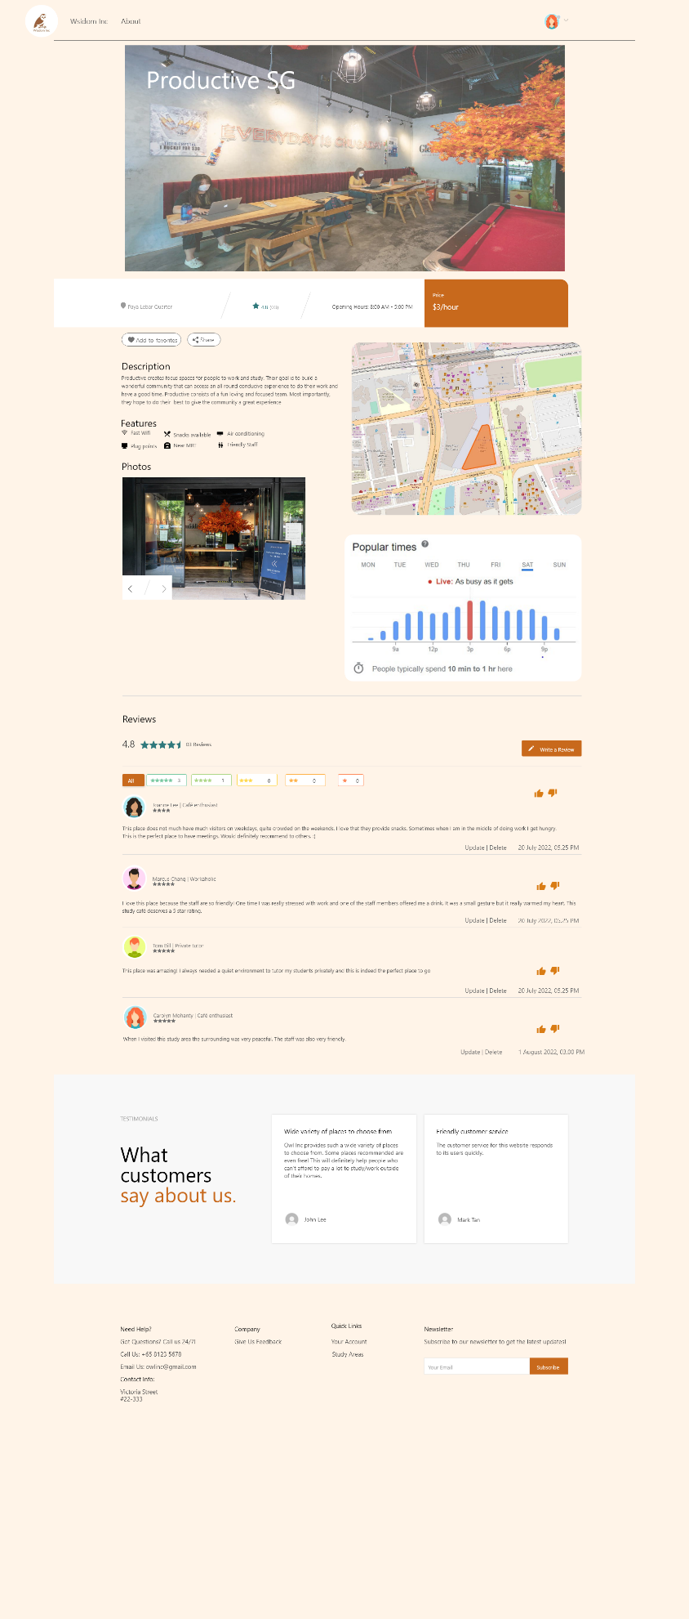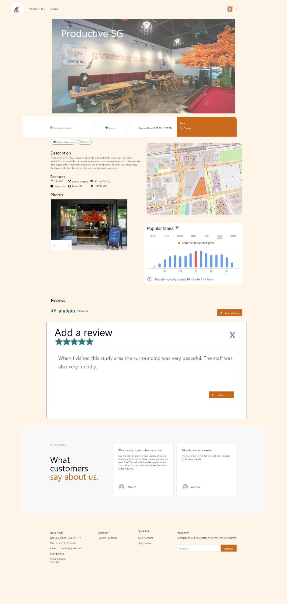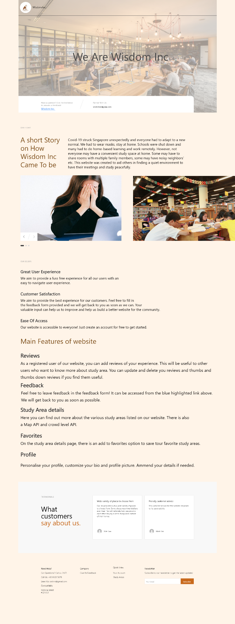

**Use Case Diagram with Descriptions (30 marks)**

Please insert the screenshot of your Use Case Diagram.

You use case diagram should include all core use cases of your whole system proposed.

Description for each core use case should be clear.

(Zoom in for clearer view)

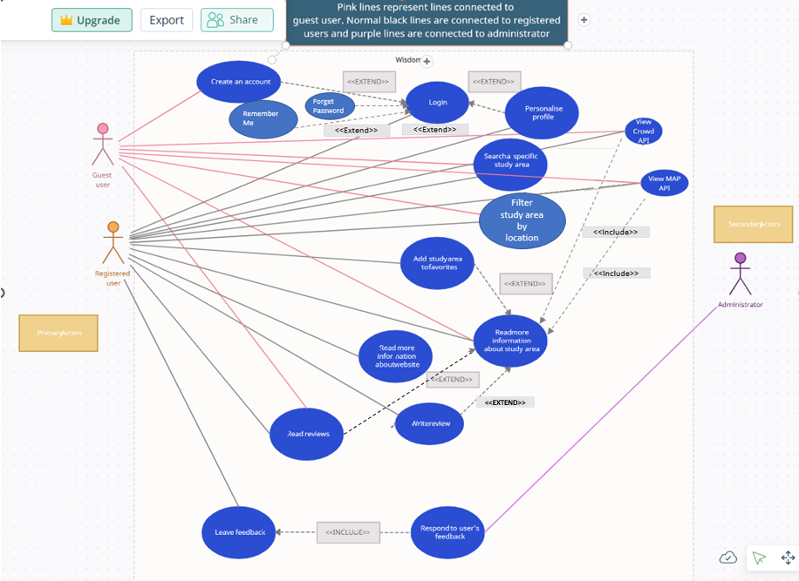

**Descriptions for each use case:**

Create Account

Guest users can create an account to gain access to additional functionalities that only registered users have. For example, writing reviews and leaving feedback.

Login

Registered users can login into their account to leave reviews & ratings on a particular study area, leave feedback for improvement of the website and personalising their profile. When the users go to the login page, they may or may not make use of the forget password and remember me function. They also may or may not personalise their profile. Hence, these functions have a extend relationship.

Personalise their profile

Registered users can amend their personal details, profile picture and bio.

Search a specific study area

Registered users and guest users can search for a specific study area that they wish to view information on instead of scrolling through the whole list of study areas.

Filter study area by location

Registered users and guest users can filter the listed study areas by location, this helps them to filter out the areas closest to them.

Read more information about study area

Guest users and registered users can view more information about the study areas. On the same page, there is an option to add to the study area to their favourites list and users can read and write reviews on the study area as well.

When a registered user views more information about the study area, they may or may not write a review, read review or add it to their favourites. Hence there is a ‘extend’ relationship between ‘read more information about study area’ and these 2 use cases. However, they will view the crowd and map API. Therefore, there is an ‘include’ relationship between ‘read more information about study area’ and these 2 use cases.

View MAP API

Both guest users and registered users can view the Map API featured on the study area details page displaying the study area’s location.

View Crowd level API

Both guest users and registered users can view the crowd level API featured on the study area details page. It will display the crowd levels of the study are at a selected timing.

Add study area to favourites

Registered users can add study areas that they want to view again or are interested into their favourites list. It makes it more convenient to be view later.

Write reviews

Registered users can write, and rate study areas based on their experiences there.

Read reviews

Both guest and registered users can read the reviews written by registered users.

Read more information about the website

Both registered users and guest users can visit the ‘about’ page to access more information about the website. This page contains information about how the website started, features of the website etc.

Leave feedback

Registered users can leave feedback to express their opinions and concerns regarding the website.

Respond to user’s feedback

Administrators can respond to user’s feedback and address their concerns. This use case has an ‘include’ relationship with leaving feedback (base use case). Every time the user leaves feedback, the administrator will respond to the feedback.

**Prototyping Sprint Activities in JIRA (40 marks)**

Provide Evidence of **activities** done in JIRA with screenshots for the following:

* Sprint Planning
* Sprint Review
* Sprint Retrospective

Please note these activities are the incremental ones from the Project Part 2 and should include more activities of how your prototype has been created/tested/validated etc.

Invite your tutor as a user in Jira and provide him/her access.

# Sprint Planning

# Sprint 3

**Sprint Goal:**

1. Define the goal of this sprint



1. What are you trying to achieve?

We are trying to achieve a more enhanced and detailed prototype which is not only user-friendly but also able to address to the user’s needs. For example, the map API and crowd level API should be clear and easy for the user to understand and use.

**Overview of Sprint:**

1. Duration of Sprint

1 week

1. Status of project and tasks

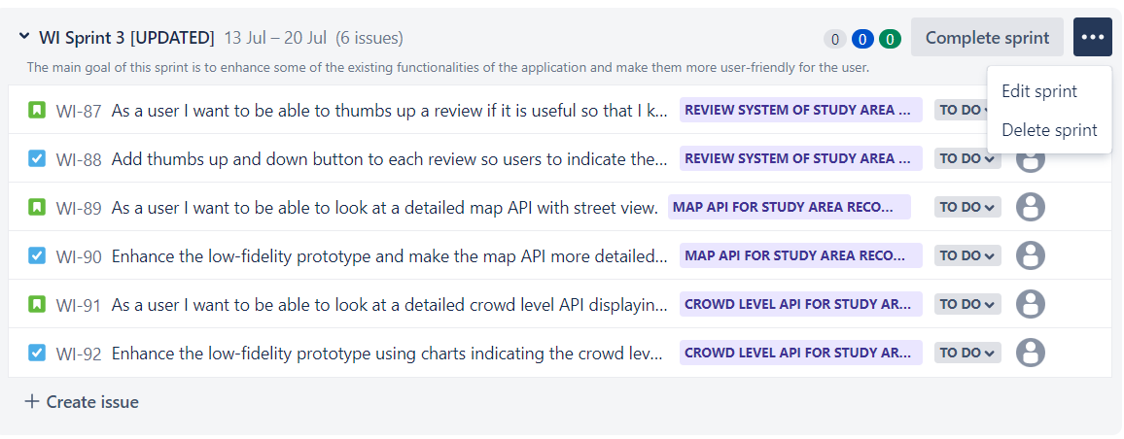

1. Number of open/closed items

There are 6 open issues before the completion of this sprint. I assigned them to their respective EPICS in the following sprint

1. Priority of remaining tasks (in backlog, will be pushed to the next sprint)

Add images of all the study areas to the low-fidelity prototype. [1]

Add a forget password option to the login page. [2]

Add a remember me option to login page. [3]

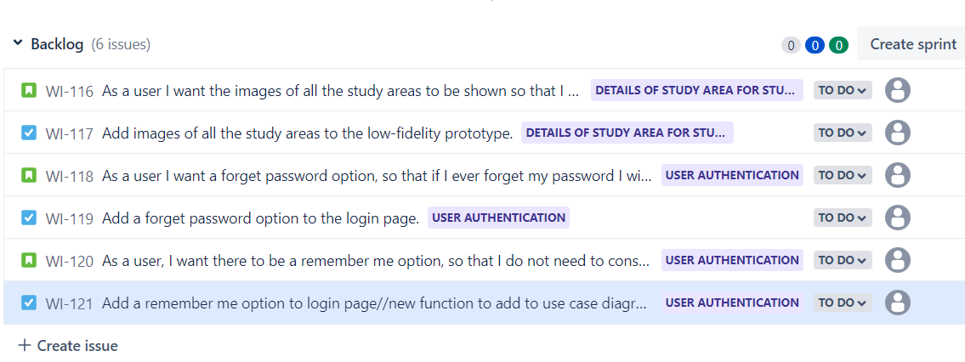

1. Completed percentage

The current completed percentage of all the tasks in Sprint 3 is 0.

# Sprint Review

Number of sprints planned: 3 Sprints

1. Forecasted user stories

User story map (screenshot before completion of tasks)

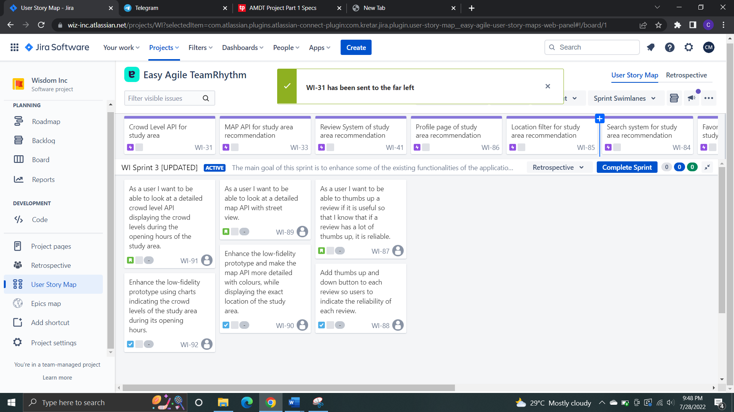

1. Completed (“Done”) user stories (at the end of the sprint)

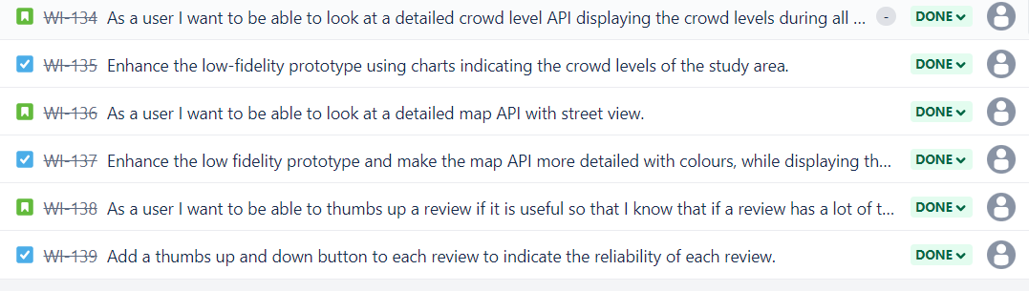

3) Number of unplanned items added to sprint

There were no unplanned items added to this sprint as all the tasks in the previous sprint had been completed.

4) Current Completion status of project (the whole project)

With all the tasks completed in Sprint 3, the project is now 65% complete.

5) Projected completion date

Projected completion date of Sprint 3 is 20 Jul.

# Sprint Planning

# Sprint 4

1. Define the goal of this sprint



1. What are you trying to achieve?

I am trying to achieve a high-fidelity prototype that is not only able to address the user’s needs but also super convenient and easy to use. For example, features like forget password is convenient for forgetful users. Features like personalizing profile increases interaction between the user and the website, providing users with a better user experience.

1. Duration of Sprint

1 Week

1. Status of project and tasks

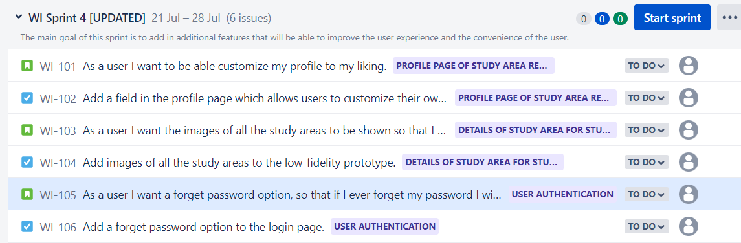

1. Number of open/closed items

There are 6 open issues before the completion of this sprint.

1. Priority of remaining tasks (in backlog)

Indicate number of reviews for each rating - 1 star, 2stars, 3 stars, 4 stars and 5 stars respectively. [1]

Add a remember me option to login page [2]

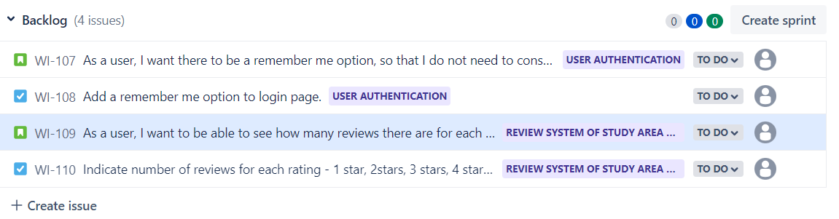

1. Completed percentage

The current completed percentage of all the tasks in Sprint 4 is 0.

# Sprint Review

Forecasted user stories

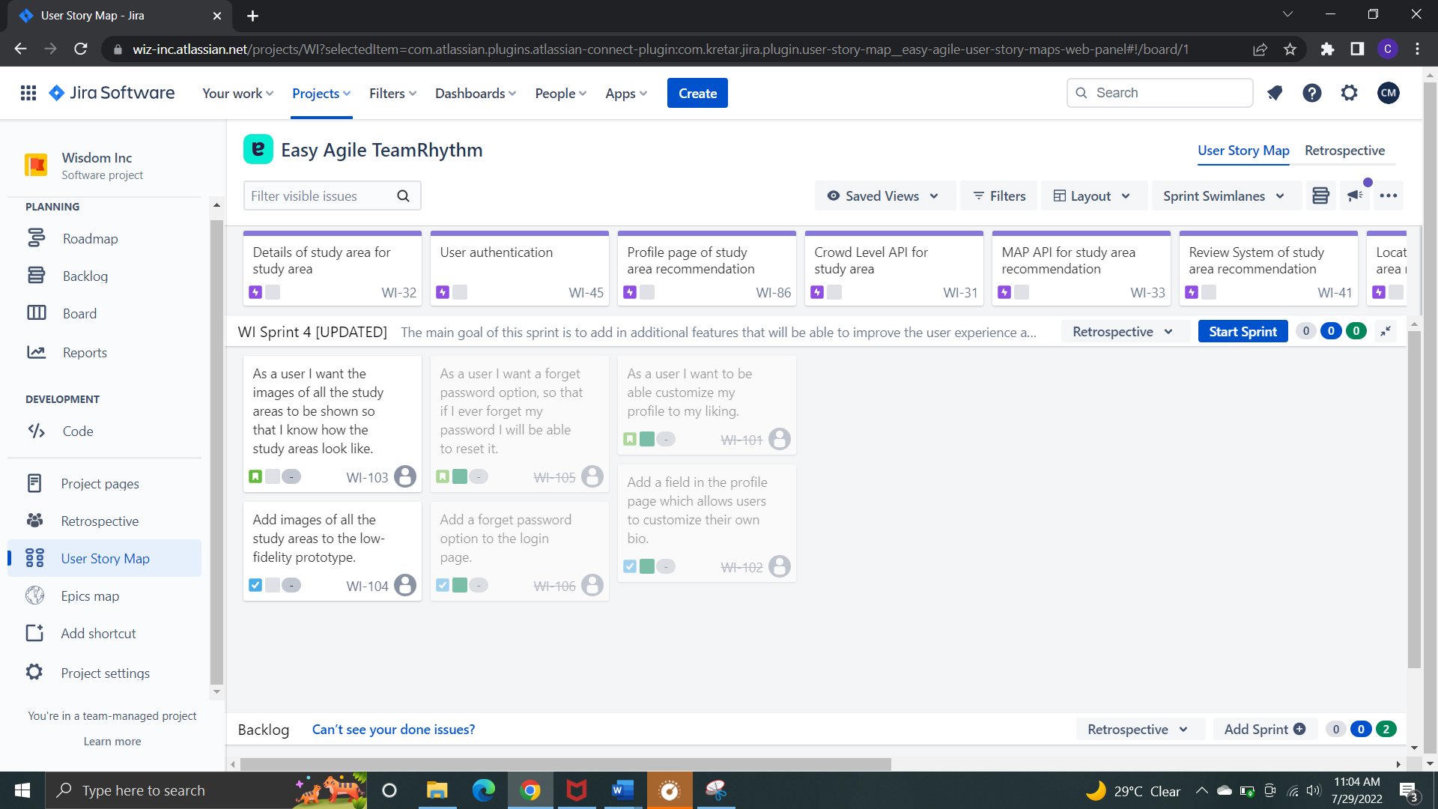

1. Completed (“Done”) user stories

As of Sprint 4 I was unable to complete 1 task which was collating and adding the images for all the study areas due to being busy with other projects as well. Hence, the 2 issues (incomplete user story and task) will be pushed to the next sprint.

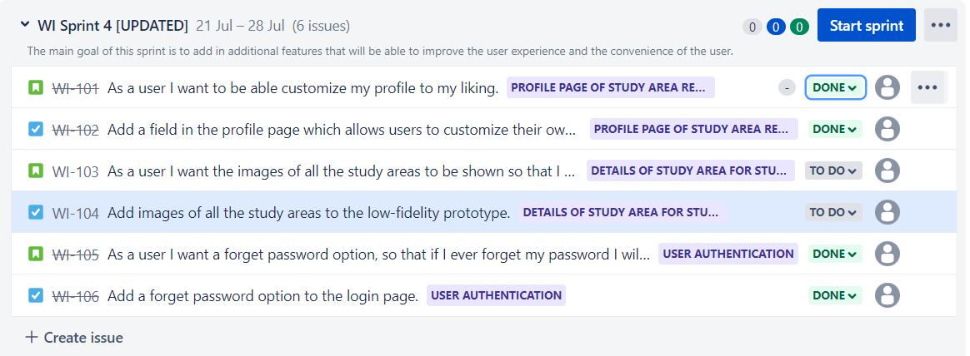

1. Number of unplanned items added to sprint

As all the tasks in Sprint 3 were completed, there were no unplanned items added to the sprint.

1. Current Completion status of project

With the 2 tasks completed in Sprint 4, the project is 75% completed. The incomplete tasks will be moved to Sprint 5.

1. Projected completion date of Sprint 4

28 July

# Sprint Planning

# Sprint 5

**Sprint Goal:**

1. Define the goal of this sprint



1. What are you trying to achieve?

Trying to finish the final functionalities of the web application to achieve the finished high-fidelity prototype.

**Overview of Sprint:**

1. Duration of Sprint

1 week

1. Status of project and tasks

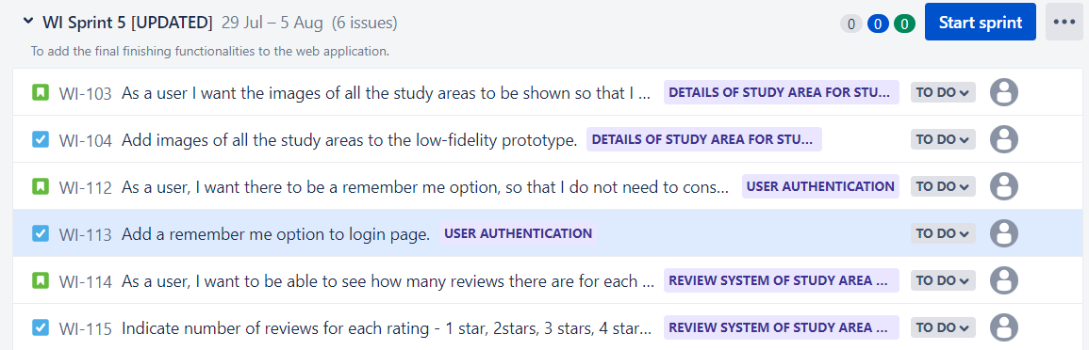

1. Number of open/closed items

There are 6 open issues before the completion of the sprint.

4) Priority of remaining tasks (in backlog)

There are no remaining tasks in the backlog as this is the final sprint.

1. Completed percentage

The completed percentage of the task in Sprint 5 is 0%. Even though 1 user story and 1 task was pushed from sprint 4 to 5. There was no progress made in that task.

# Sprint Review

1. Forecasted user stories (user story map before completion of sprint)

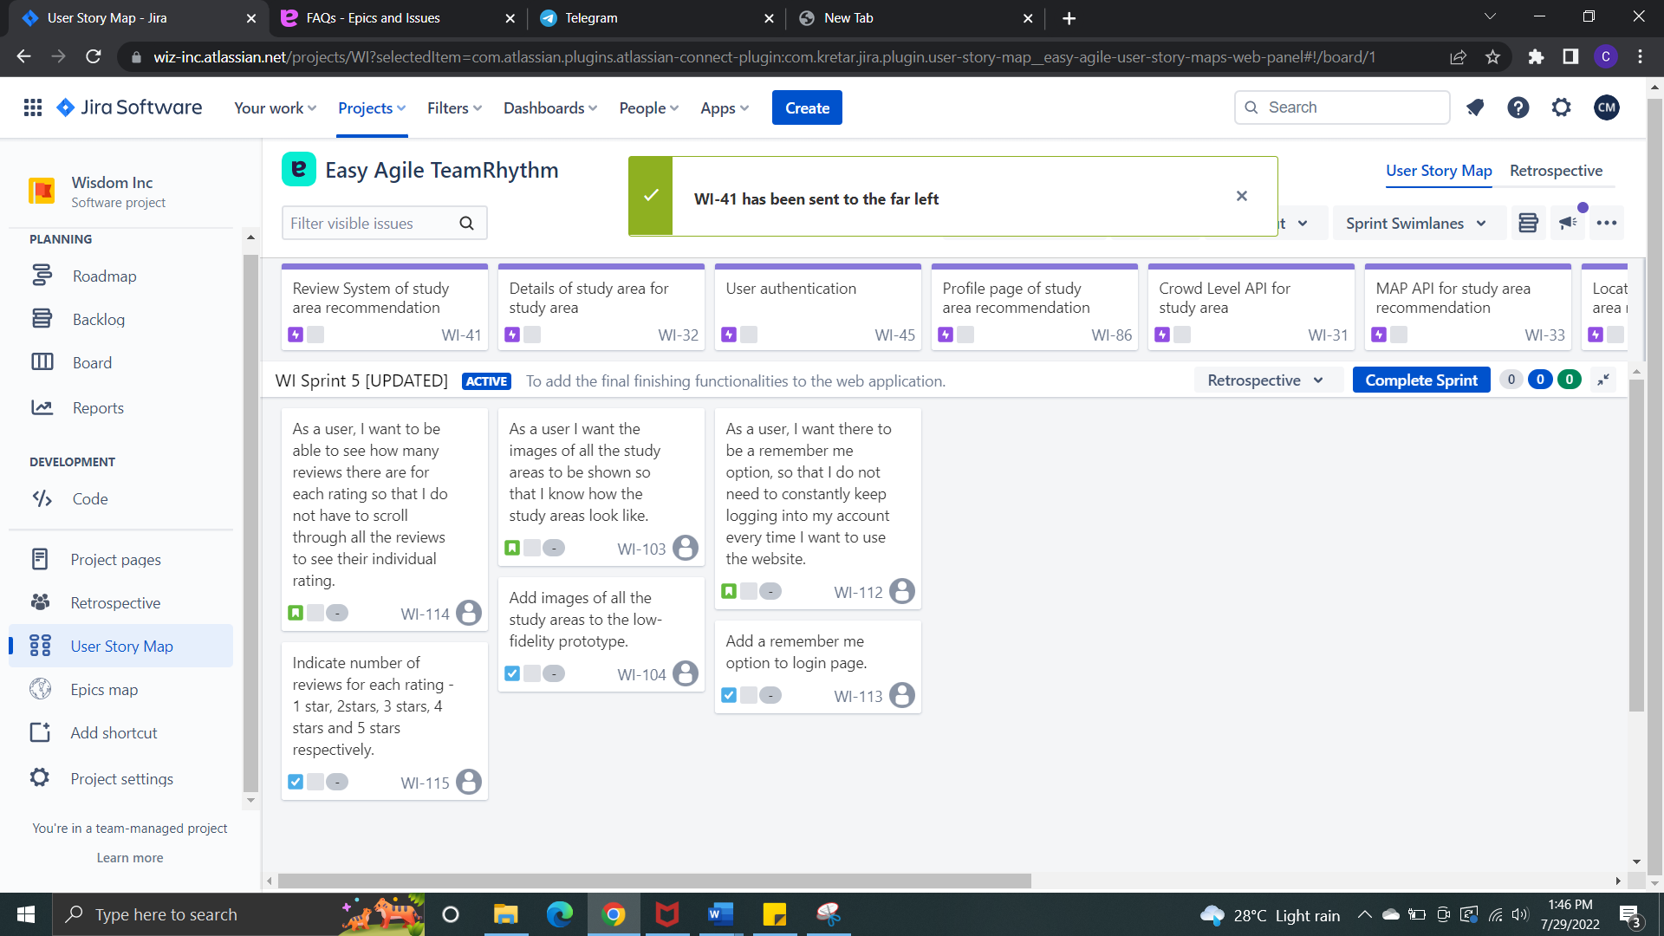

1. Completed (“Done”) user stories

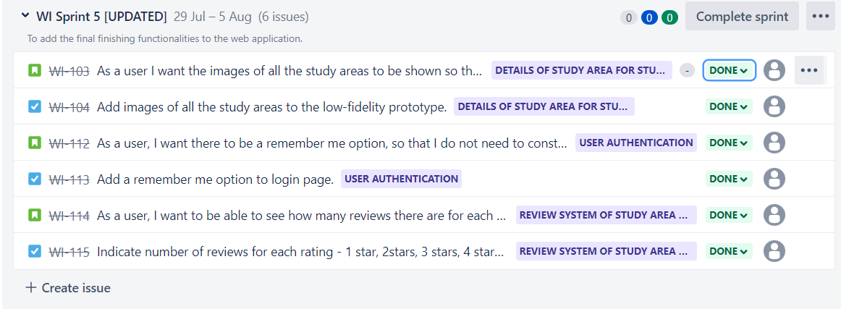

1. Number of unplanned items added to sprint

Originally, I had not planned to add images of all the study areas to the low-fidelity prototype in Sprint 5. It was supposed to be completed in Sprint 4. However, because I was unable to complete it in Sprint 4, it was pushed to Sprint 5.

1. Current Completion status of project

The project is about fully complete after completion of all the tasks in Sprint 5.

1. Projected completion date of Sprint 5

5 Aug

# Acceptance Criteria of all the sprints

Acceptance criteria

As a user I want to be able to like other people’s comments if I find them useful so that I know if a review has a lot of thumbs up it is reliable.

* There should be a thumbs up and down button for user to up vote and downvote a review. This is to indicate the reliability of the review.

As a user I want to be able to look at a detailed map API with street view.

* Map API should have colors highlighting the exact location of the study area on the street view of the map.
* Map API should only display the study area location in street view.

As a user I want to be able to look at a detailed crowd level API displaying the crowd levels during the opening hours of the study area.

* API should use bar charts to display the crowd levels during the opening hours.
* The bar chart that is red should indicate the timing with the highest crowd level. The rest of the bar charts should be blue.

As a user I want to be able customize my profile to my liking.

* User should be able to customize their profile picture as well as their bio.

As a user I want the images of all the study areas to be shown so that I know how the study areas look like.

* All study areas should have their images displayed on the home page and study area details page.

As a user I want a forget password option, so that if I ever forget my password, I will be able to reset it.

* Forget password option should allow users to enter their email so that they can receive an email to reset their password on the sign in page.

As a user, I want there to be a remember me option, so that I do not need to constantly keep logging into my account every time I want to use the website.

* There should be a check box on the sign in page, when users check this check box it will indicate that the next time, they visit the website they will automatically be signed in.

As a user, I want to be able to see how many reviews there are for each rating so that I do not have to scroll through all the reviews to see their individual rating.

* At the top of the review section, there should be a row of stars – 1 star, 2 stars, 3 stars, 4 stars and 5 stars. Next to each of the stars there should be a number indicating how many reviews there are with that particular rating(of stars).

# Sprint Retrospective

# Sprint 3

1. What went right in this sprint?

I was able to complete all the tasks planned and specified for this sprint.

1. What went wrong in this sprint?

Some of the acceptance criteria were confusing and not very specific. Had to make some modifications along the way.

1. What could be improved on?

Before picking any user stories for the sprint, each user story should have a clear acceptance criteria.

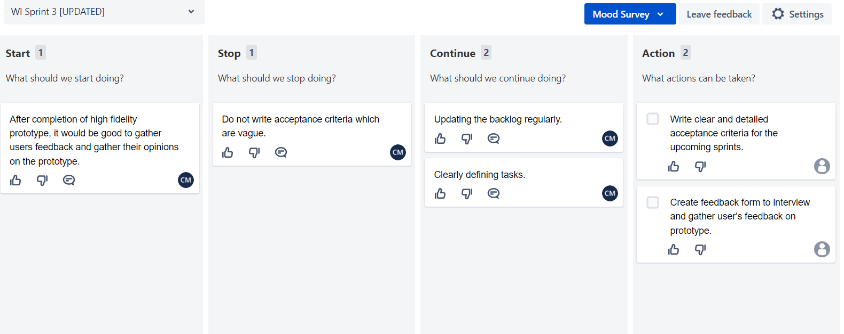

# Sprint 4

1. What went right in this sprint?

Tasks were clearly defined. I knew exactly what I had to complete and why I had to complete it.

1. What went wrong in this sprint?

I was not able to complete 2 issues. It was hard managing time between multiple projects and as a result I was unable to complete these 2 issues and had to push it to the following sprint. Another problem I faced was procrastination.

1. What could be improved on?

As mentioned in the earlier part, I had a problem with time management and procrastination. Downloading a productivity app can help to reduce my procrastination, help me stay focus and stay productive (since this is an individual project).

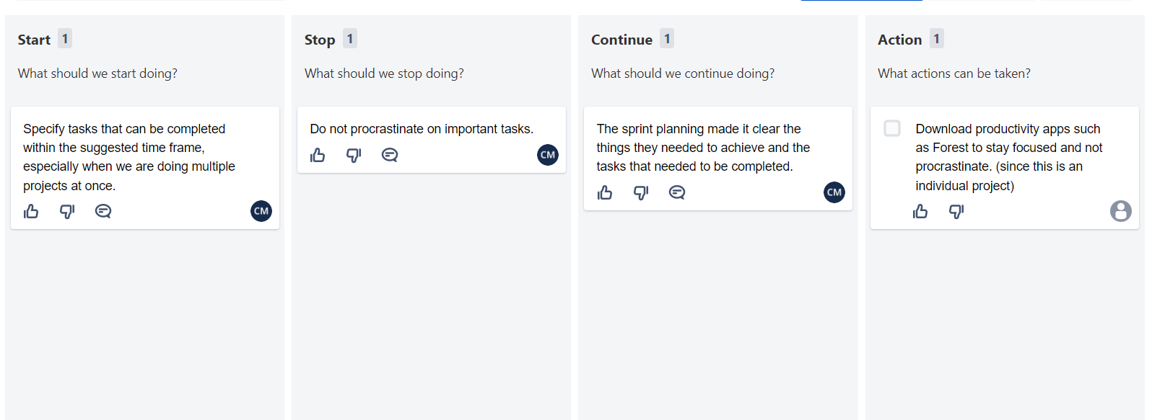

# Sprint 5

1. What went right in this sprint?

In the previous sprint, I was unable to complete 2 issues. As a result, I had to push the incomplete issues to sprint 5. However, in this sprint I was able to get back on track and complete all the required tasks to complete my high-fidelity prototype.

1. What went wrong in this sprint?

It was difficult finding images for certain study areas in Singapore for one of the issues, especially the less well-known ones like those in the community centres.

1. What could be improved on?

Should improve on research techniques, research should not only be limited to researching online, but visiting the study areas itself or consulting other people.

We can consider visiting the study areas and photographing its location.

